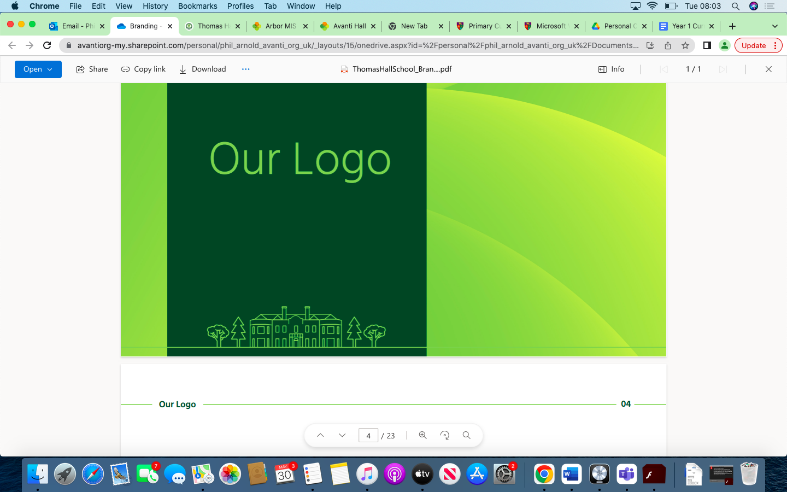

Maths Overview Thomas Hall School 2023-2024

|  |
| --- |
| Early Years and Key Stage 1 |
| Key Stage 2 |
| Key Stage 3 |
| Key Stage 4 |

|  |  |  |  |  |  |  |
| --- | --- | --- | --- | --- | --- | --- |
| **Year** | **Autumn 1** | **Autumn 2** | **Spring 1** | **Spring 2** | **Summer 1** | **Summer 2** |
| **Reception** | Count objects, actions and sounds.  Subitise.  Link the number symbol (numeral) with its cardinal number value. | Link the number symbol (numeral) with its cardinal number value.  Continue, copy and create repeating patterns.  **Subitise (recognise quantities without counting) up to 5.** | Count beyond ten.  Compare numbers.  Understand the ‘one more than/one less than’ relationship between consecutive numbers.  Explore the composition of numbers to 10.  Select, rotate and manipulate shapes to develop spatial reasoning skills.  **Compare quantities up to 10 in different contexts, recognising when one quantity is greater than, less than or the same as the other quantity.** | Automatically recall number bonds for numbers 0-5 and some to 10.  Compose and decompose shapes so that children recognise a shape can have other shapes *within it*, just as numbers can. **Have a deep understanding of number to 10, including the composition of each number.**  **Automatically recall (without reference to rhymes, counting or other aids) number bonds up to 5 (including subtraction facts) and some number bonds to 10, including double facts.** | Compare length, weight and capacity.  **Verbally count beyond 20, recognising the pattern of the counting system.**  **Explore and represent patterns within numbers up to 10, including evens and odds, double facts and how quantities can be distributed equally.** | **Comparing quantities and objects related to size, weight, capacity, position, distance, time and money.**  **Addition, subtraction, sharing.** |
| **Year 1** | Place Value to 10  Addition & Subtraction to 10 | Addition & Subtraction to 10  Geometry | Place Value to 20  Addition & Subtraction within 20 | Place Value to 50  Length & Height  Mass & Volume | Multiplication and Division  Fractions | Geometry  Place Value to 100  Money  Time |
| **Year 2** | Place Value  Addition & Subtraction | Addition & Subtraction  Shape | Money  Multiplication & Division | Multiplication & Division  Length & Height  Mass, Capacity & Temperature | Fractions  Time | Time  Statistics  Position & Direction |
| **Year 3** | Place Value  Addition & Subtraction | Addition & Subtraction  Multiplication & Division | Multiplication & Division  Length & Perimeter | Fractions  Mass & Capacity | Mass & Capacity  Revisit Fractions  Money  TIme | Time  Shape  Statistics |
| **Year 4** | Place Value  Addition & Subtraction | Addition & Subtraction  Measurement – Area  Multiplication & Division | Multiplication & Division  Length & Perimeter  Fractions | Fractions  Decimals | Decimals  Money  Revisit Multiplication | Time  Shape  Statistics  Position & Direction |
| **Year 5** | Place Value  Addition & Subtraction Multiplication & Division | Multiplication & Division  Fractions | Multiplication & Division  Fractions  Decimals & Percentages | Decimals & Percentages  Perimeter & Area  Statistics | Geometry  Position & Direction | Decimals  Negative Numbers  Measures – Converting Units  Measures - Volume |
| **Year 6** | Place Value  Addition, Subtraction, Multiplication & Division | Addition, Subtraction, Multiplication & Division  Fraction  Measures – Converting Units | Ratio  Algebra  Decimals | Decimals & Percentages  Area, Perimeter & Volume  Statistics | Shape  Position & Direction  Revision of Content | Themed Projects, Consolidation  Problem Solving |
| **Year 7** | Algebraic Thinking  Sequences  Understand and use algebraic notation  Equality and equivalence | Place Value and Proportion  Place value, ordering integers and decimals  Fraction, decimal and percentage equivalence | Applications  Solving Problems with Addition/Subtraction  Solving Problems with Multiplication/Division  8. Fractions & percentages of amounts | Directed Number  Fractional Thinking  Operations and equations with directed number.  Addition and subtraction of fractions | Lines and angles  Constructing, measuring and using geometric notation.  Developing geometric reasoning | Reasoning with Number  Developing number sense  Sets and probability  Prime numbers and proof |
| **Year 8** | Proportional Reasoning    Ratio and Scale  Multiplicative Change  Multiplying and dividing fractions | Representations      Cartesian plane  Representing Data  Tables and probability | Algebraic Techniques      Brackets, equations and inequalities  Sequences  Indices | Developing Number  Fractions and Percentages  Standard Index Form  Number Sense | Developing Geometry    Angles in parallel lines and polygons  Area of trapezia and circles  Line symmetry and reflection | Reasoning with Data    The Data Handling Cycle  Measures of Location |
| **Year 9** | Number, powers, decimals, HCF and LCM, roots and rounding  Number - factors, multiples, indices, standard form and surd | Expressions, substitution into simple formulae, expanding and factorising  Algebra, expanding, factorising, equations, formulae and sequence | Graphs, tables and charts  Fractions and percentages  Interpreting and representing data  Fractions, ratio and percentages | Solving equations with brackets  Angles and trigonometry | Properties of shape and angles  Statistics, sampling and averages  Graphs  Area and volume | Perimeter, area and volume 1  Transformations and constructions |
| **Year 10** | Number, powers, decimals, HCF and LCM, roots and rounding    Expressions, substitution into simple formulae, expanding and factorising    Graphs, tables and chart  Number - factors, multiples, indices, standard form and surds  Algebra, expanding, factorising, equations, formulae and sequences  Interpreting and representing data | Fractions and percentages    Equations, inequalities and sequences  Fractions, ratio and percentages  Angles and trigonometry | Properties of shape and angles    Statistics, sampling and averages    Perimeter, area and volume 1  Graphs  Area and volume  Transformations and constructions | Graphs, linear and real life    Transformations  Equations and inequalities  Probability | Ratio and proportion  Trigonometry    Probability  Multiplicative reasoning, compound measures  Similarity and congruence  More trigonometry | Multipliative reasoning, compound measures, direct and inverse proportion  Construction, loci and bearings  Further statistics  Equations and graphs |
| **Year 11** | Quadratic equations and graphs  Perimeter, area and volume  Fractions, indices and Standard form | Congruence Similarity and vectors  Further advanced algebra  Mock exam 1 | Feedback and review from Mock exam 1 | Problem solving and individualised exam preparation.  Mock exam 2 | Consolidation, past papers and exam practice | Exam period |