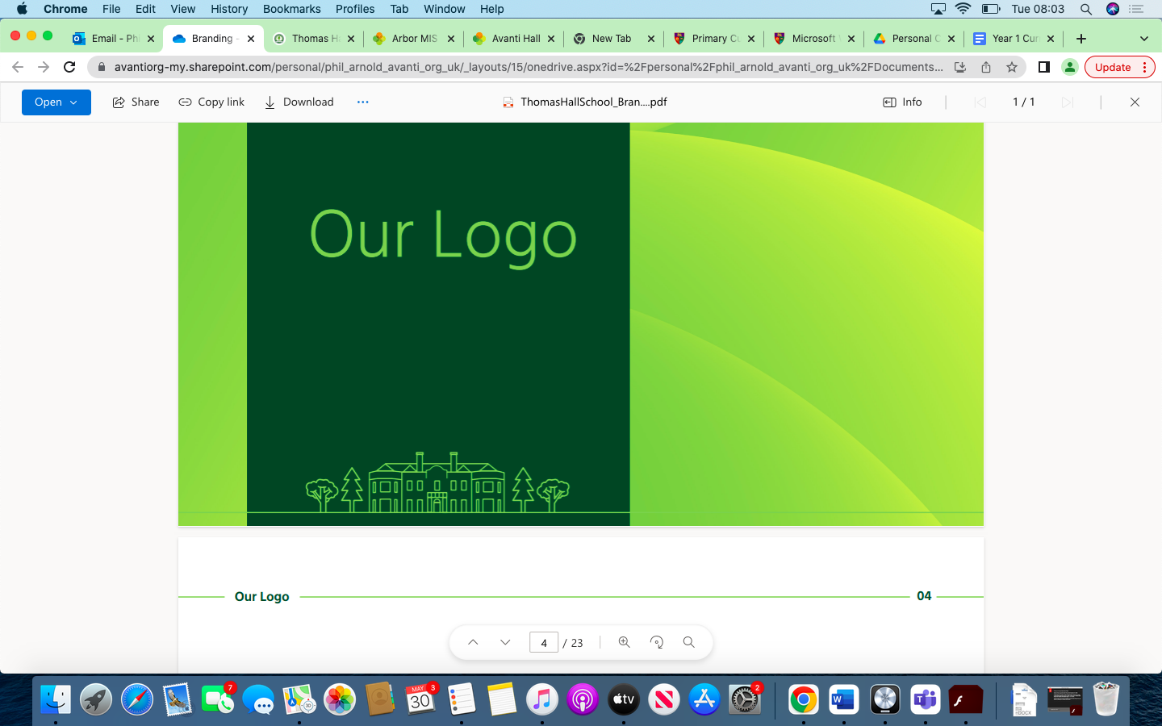

PE Overview Thomas Hall School 2023-2024

|  |
| --- |
| Early Years and Key Stage 1 |
| Key Stage 2 |
| Key Stage 3 |
| Key Stage 4 |

|  |  |  |  |  |  |  |
| --- | --- | --- | --- | --- | --- | --- |
| **Year** | **Autumn 1** | **Autumn 2** | **Spring 1** | **Spring 2** | **Summer 1** | **Summer 2** |
| **Reception** | Confidently and safely use a range of large and small apparatus indoors and  outside, alone and in a group.  Negotiate space and obstacles safely, with consideration for themselves and others. | Confidently and safely use a range of large and small apparatus indoors and  outside, alone and in a group.  Negotiate space and obstacles safely, with consideration for themselves and others. | Revise and refine the fundamental movement skills they have already acquired:  - rolling  - crawling  - walking  - jumping  - running  - hopping  - skipping  - climbing  Develop overall body-strength, balance, co-ordination and agility. | Progress towards a more fluent style of moving, with developing control and grace.  Combine different movements with ease and fluency.  Further develop and refine a range of ball skills including: throwing, catching, kicking, passing, batting, and aiming.  Begin to show accuracy and care when drawing. | Move confidently in a range of ways .  Develop the overall body strength, co-ordination, balance and agility needed to engage successfully with future physical education sessions and other physical disciplines including dance, gymnastics, sport and swimming.  Develop confidence, competence, precision and accuracy when engaging in  activities that involve a ball.  Move energetically, such as running, jumping, dancing, hopping, skipping and climbing. | Demonstrate strength, balance and coordination when playing.  Move energetically, such as running, jumping, dancing, hopping, skipping and climbing. |
| **Year 1** | Fundamentals: explore the fundamental skills of balancing, running, changing direction, jumping, hopping and skipping. They will explore these skills in isolation as well as in combination. Pupils will be given opportunities to identify areas of strength and areas for improvement. Pupils will work collaboratively with others, taking turns and sharing ideas. | Gymnastics: In this unit pupils explore and develop basic gymnastic actions on the floor and using low apparatus. Basic skills of jumping, rolling, balancing and travelling are used individually and in combination to create movement sequences. Pupils are given opportunities to select their own actions to build short sequences and develop their confidence in performing. Pupils begin to understand the use of levels, directions and shapes when travelling and balancing. | Yoga: Pupils learn about mindfulness and body awareness. They begin to learn poses and techniques that will help them to connect their mind and body. The unit looks to improve well being by building strength, flexibility, co-ordination and balance. The learning includes breathing and meditation through fun and engaging activities. Pupils work independently, with a partner and small group. | Ball Skills: Target games are games where players send an object towards a target. In this unit, pupils develop their understanding of the principles of defending and attacking for target games. Pupils use both underarm and overarm actions and are given opportunities to select and apply the appropriate action for the target considering the size and distance of the challenge. They will apply their skills individually, in pairs and in small groups and begin to organise and self-manage their own activities. They will understand the importance of abiding by rules to keep themselves and others safe, learn how to score points and use simple tactics. They show respect towards others when playing competitively and develop communication skills. | Fundamentals:  Rolling, dribbling, kicking & striking | Fundamentals: Striking with 1 or 2 hands, striking with equipment |
| **Year 2** | Fundamentals:  Forwards, backwards and side to side running | Gymnastics & Dance | Fundamentals: Finding Space, hopping, skipping, throwing under & overarm | Fundamentals: Catching, Throwing to a target and rolling | Fundamentals:  Dribbling, kicking & striking with equipment | Fundamentals: Attacking & defending  Outdoor Active Learning |
| **Year 3** | Building Games  Goal Ball | Gymnastics | Floor Ball / Hockey | Handball | Basketball | Outdoor Challenges  Treasure Maps |
| **Year 4** | Creative Thinking Games  Dive Ball | Dance | Floor Ball | Tchoukball | Capture the Flag Games | Tennis |
| **Year 5** | Healthy Eating  Dive Ball | Gymnastics | Swimming | Football | Capture the Flag Games | Basketball  Athletics |
| **Year 6** | Healthy Lifestyles  Dodgeball | Gymnastics  Dance | Swimming | Volleyball | Cricket | Orienteering  Athletics |
| **Year 7** | **Football**  *Passing techniques and possession*  situation  *Shooting techniques and safe tackling* | **Dance**  *Range of dance movements and contrasts in dynamic and rhythmic patterning* | **Basketball**  *Shooting techniques* | **Gymnastics**  *Cartwheel, round off and vaulting*  *Rolls and handstands* | **Rounders**  *Throwing and catching*  *Batting, bowling and backstop* | **Athletics**  *Introduction to athletic events, basic techniques and safety points.* |
| **Year 8** | Tennis  *Ground strokes, outwitting the opponents, volley and serve* | Handball  *Passing technique, Rules of the game.* | Rugby  *Passing and introduction of rules, base game on tag rugby.* | Netball  *Passing, positions and zones* | Table Tennis  *Introduction to table tennis, grip and push shots.* | Cricket  *Throwing and catching* |
| **Year 9** | Volleyball  *Dig, set and serve*  *Movement and communication*  *Spiking* | Netball  *Contact/obstruction and shooting*    *Shooting and rebounds* | Basketball  *Defensive and attacking play* | Gymnastics  *Somersaults* | Rounders  *Throwing and catching*    *Batting, bowling and backstop* | Athletics |
| **Year 10** | Cricket  *Bowling and batting* | Netball  *Advanced footwork and passing*  *Recap* | Gymnastics  *Somersaults* | Gymnastics  *Handstand/handspring* | Athletics | Football  *Movement off the ball and throw ins*  *Offside rule and goal keeping* |
| **Year 11** |  |  |  |  |  |  |