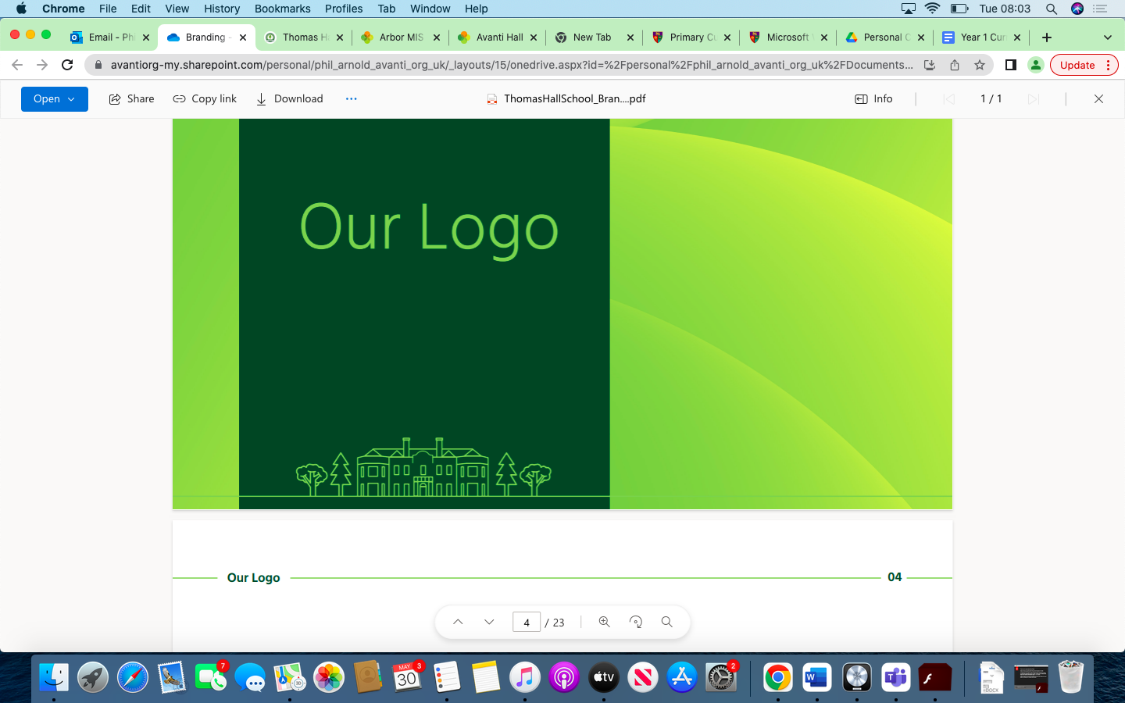

History Overview Thomas Hall School 2023-2024

|  |
| --- |
| Early Years and Key Stage 1 |
| Key Stage 2 |
| Key Stage 3 |
| Key Stage 4 |

|  |  |  |  |  |  |  |
| --- | --- | --- | --- | --- | --- | --- |
| **Year** | **Autumn 1** | **Autumn 2** | **Spring 1** | **Spring 2** | **Summer 1** | **Summer 2** |
| **Reception** | Family routines. | Family customs.  Talk about past and present events in their and their family’s lives.  Comment on images of familiar situations in the past. | Compare and contrast characters from stories, including figures from the past. | Compare and contrast characters from stories, including figures from the past. | Know some similarities and differences between things in the past and now, drawing on their experiences and what has been read in class. | Know some similarities and differences between things in the past and now, drawing on their experiences and what has been read in class. |
| **Year 1** | Change in Living Memory |  | Lives of Significant Individuals |  | More Lives of Significant Individuals |  |
| **Year 2** | Events Beyond Living Memory (Great Fire of London) |  |  | Local History |  |  |
| **Year 3** |  | Stone Age to Iron Age |  | Revisit Stone Age to Iron Age | Roman Empire |  |
| **Year 4** | Anglo Saxon Kingdoms |  |  | Vikings | Ancient Civilizations - Egypt |  |
| **Year 5** |  | Ancient Greeks |  |  |  | Contrasting Non-European Society – The Maya |
| **Year 6** | Local History Study – How did WW2 change Exeter? |  | Windrush Generation |  |  | Study of UK Monarchs |
| **Year 7** | Black Death  An introduction to the medieval world and a study of the impact of the Black Death on Britain | Black Death  An introduction to the medieval world and a study of the impact of the Black Death on Britain | How should Plymouth remember the Mayflower?  To understand that the story of the Mayflower is an interpretation. | How should Plymouth remember the Mayflower?  To be able to analyse the impact of the Mayflower on the Wampanoag? | Modern Britain  How did Britain become modern | Impact of War  Impact of war on Plymouth and people from the area. |
| **Year 8** | Anglo Saxon England      A study of Anglo-Saxon England and  the battles of 1066 | Anglo Saxon England      A study of Anglo-Saxon England and  the battles of 1066 | What was the impact of Henry’s divorce on England?    A study of the causes and impact of the Reformation | What was the impact of Henry’s divorce on England?    A study of the causes and impact of the Reformation | What lay behind Britain’s transatlantic slave trade? (World Study)    World Study | WW2        Key Turning points of World War 2 |
| **Year 9** | How and why did Hitler go from loser to leader?  To what extent did Germans become Nazis?  The Rise of Hitler and his rule of Germany 1933-1945 | How and why did Hitler go from loser to leader? To what extent did Germans become Nazis?    The Rise of Hitler and his rule of Germany 1933-1945 | WW2 (This unit to be updated for next year).        Examining turning points in WW2 | How has the Holocaust been remembered?        A study of the Holocaust | Introduction to cold war      Introduction to the beginning of the cold war following the GCSE course. | Introduction to cold war    Introduction to the beginning of the cold war following the GCSE course. |
| **Year 10** | Weimar and Nazi Germany, 1918–39      Modern depth study | Weimar and Nazi Germany, 1918–39      Modern depth study | Crime and punishment in Britain, c1000–present    Thematic study and historic environment | Crime and punishment in Britain, c1000–present     Thematic study and historic environment | Whitechapel, c1870–c1900: crime, policing and the inner city.    Thematic study and historic environment | Superpower relations and the Cold War, 1941–91  Period study and British depth study |
| **Year 11** | Superpower relations and the Cold War, 1941–91  Period study and British depth study | Elizabethan England 1558 – 1588  British Depth Study with Historic Environment | Elizabethan England 1558 – 1588  British Depth Study with Historic Environment | Revision | Revision | Examinations |