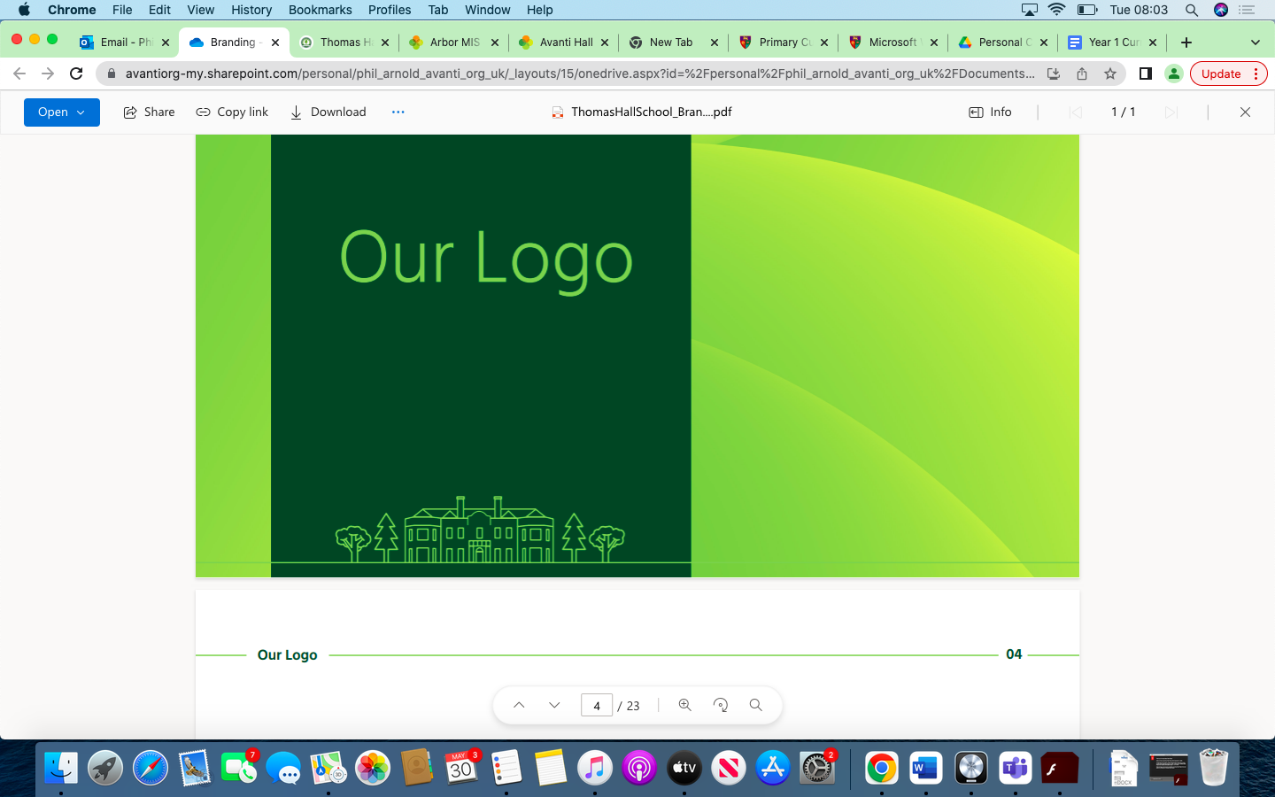

Design and Technology Overview Thomas Hall School 2023-2024

|  |
| --- |
| Early Years and Key Stage 1 |
| Key Stage 2 |
| Key Stage 3 |
| Key Stage 4 |

|  |  |  |  |  |  |  |
| --- | --- | --- | --- | --- | --- | --- |
| **Year** | **Autumn 1** | **Autumn 2** | **Spring 1** | **Spring 2** | **Summer 1** | **Summer 2** |
| **Reception** | Mark making and drawing shapes.  Create collaboratively, sharing ideas, resources and skills. | Mark making and drawing shapes.  Create collaboratively, sharing ideas, resources and skills. | Safely use and explore a variety of materials, tools and techniques, experimenting with colour, design, texture, form and function. | Safely use and explore a variety of materials, tools and techniques, experimenting with colour, design, texture, form and function. | Explore the natural world around them, making observations and drawing pictures of animals and plants. | Explore the natural world around them, making observations and drawing pictures of animals and plants. |
| **Year 1** | Mechanisms | Structures |  | Food & Nutrition 1  Understanding Materials | Textiles | Food & Nutrition 2 |
| **Year 2** | Textiles | Food and Nutrition 1 | Mechanisms | Understanding Materials | Food and Nutrition 2 | Structures |
| **Year 3** | Textiles | Food & Nutrition 1 | Mechanisms | Food & Nutrition 2 |  | Systems  Structures |
| **Year 4** | Food & Nutrition 1 | Mechanisms | Textiles (sewing) | Structures |  | Electrical Systems  Food & Nutrition 2 |
| **Year 5** | Food & Nutrition | Systems | Textiles | Food & Nutrition | Structures | Mechanisms |
| **Year 6** | Food and Nutrition 1 | Mechanisms | Food and Nutrition 2  Structures |  | Electrical Systems | Textiles |