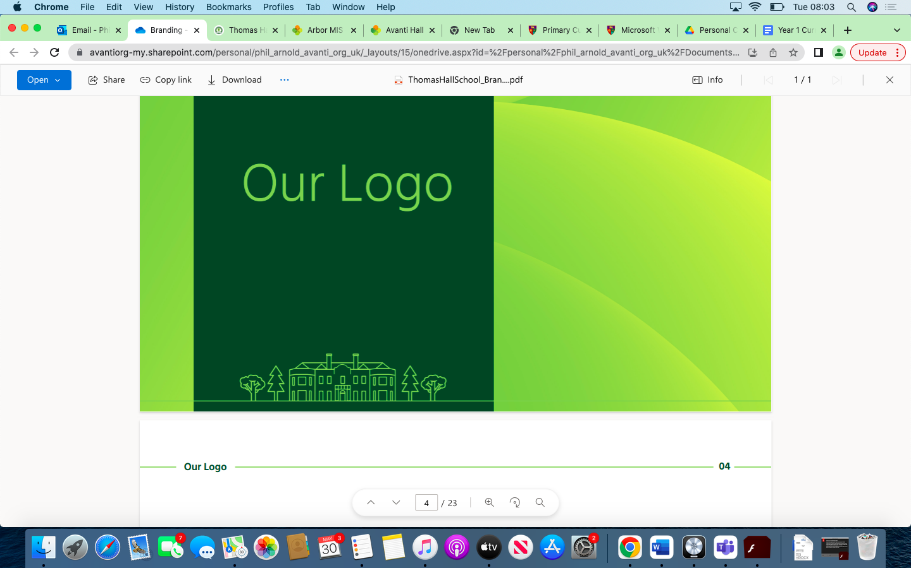

Music Overview Thomas Hall School 2023-2024

|  |
| --- |
| Early Years and Key Stage 1 |
| Key Stage 2 |
| Key Stage 3 |
| Key Stage 4 |

|  |  |  |  |  |  |  |
| --- | --- | --- | --- | --- | --- | --- |
| **Year** | **Autumn 1** | **Autumn 2** | **Spring 1** | **Spring 2** | **Summer 1** | **Summer 2** |
| **Reception** | Create collaboratively, sharing ideas, resources and skills. | Listen attentively, move to and talk about music, expressing their feelings and responses.  Sing in a group or on their own, increasingly matching the pitch and following the melody. | Sing a range of well-known nursery rhymes and songs. | Sing a range of well-known nursery rhymes and songs. | Explore and engage in music making and dance, performing solo or in groups. | **Perform songs, rhymes, poems and stories with others, and (when appropriate) try to move in time with music.** |
| **Year 1** | Being Together in Music | Introducing Rhythm & Pulse | Introducing Pitch | Introducing Tempo & Dynamics | Exploring Emotions in Music | Experimenting with Sounds |
| **Year 2** | Experimenting with Sounds | Being Together in Music | Introducing Rhythm & Pulse 2 | Introducing Pitch 2 | Introducing Tempo & Dynamics 2 | Exploring Emotions Through Music |
| **Year 3** | Introducing Singing in Rounds | Untuned Percussion | The History of Singing | Musical Notation | Composition | Introducing Timbre |
| **Year 4** | Untuned Percussion | Introducing Texture | Musical Notation 2 | The History of Singing 2 | Composition 2 | Introducing Timbre 2 |
| **Year 5** | Untuned Percussion | Introducing Structure | Musical Notation 3 | Singing | Composition | Improvisation |
| **Year 6** | Singing | Music Technology | Introducing Structure 2 | Musical Notation 4 | Composition 4 | Improvisation 2 |
| **KS3**  Scaled to year group. | Elements of Music. | Developing rhythms, scales and pitches from around the World. | Acquiring foundation performance knowledge. | Developing knowledge of composition. | The science of sound.  Acoustics and psychoacoustics. | Acquiring foundation ensemble performance. |
| **Year 10** | N/A | N/A | N/A | N/A | N/A | N/A |
| **Year 11** | BTEC - Unit 4  Introduction to DAW production. | BTEC - Unit 6  Plan and create a music product for a brief. | BTEC - Unit 1  Introduction to recording. | Finalising the BTEC course. | Finalising the BTEC course. | Finalising the BTEC course. |