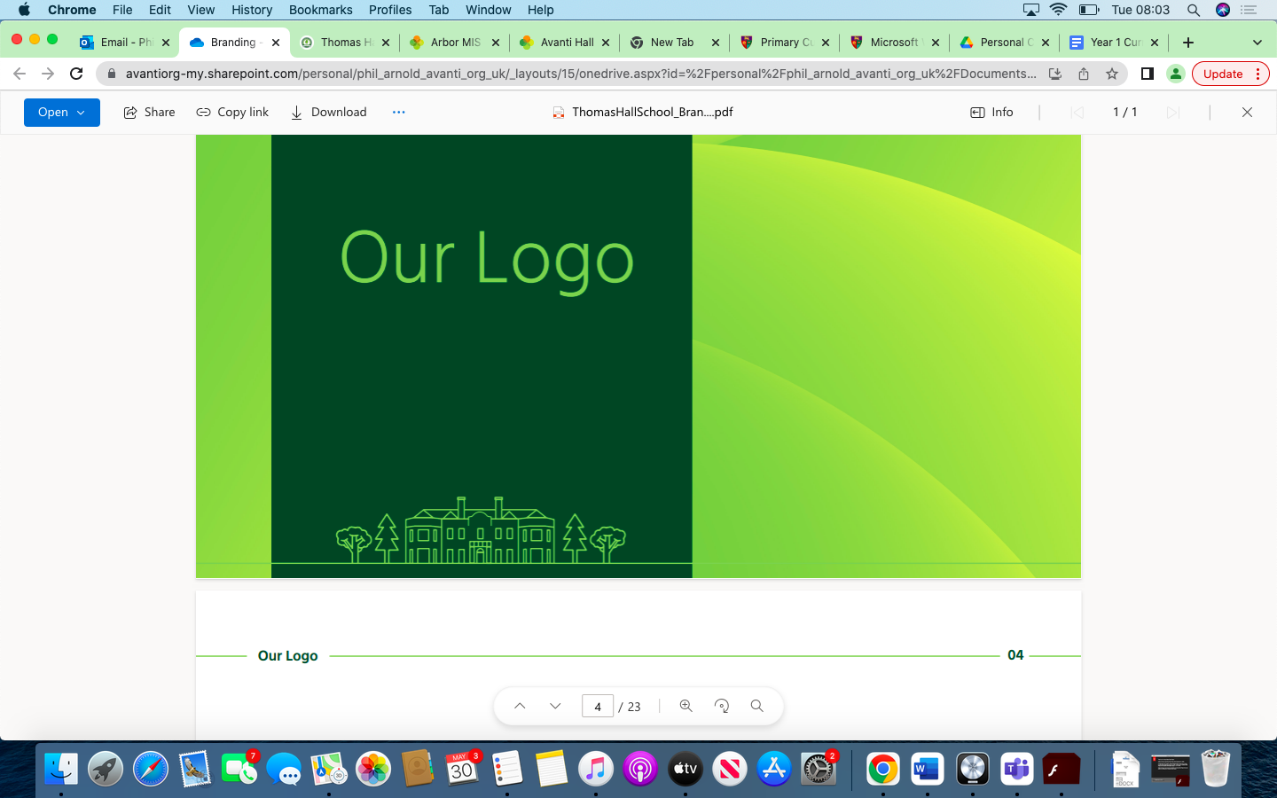

PHSE Overview Thomas Hall School 2023-2024

|  |
| --- |
| Early Years and Key Stage 1 |
| Key Stage 2 |
| Key Stage 3 |
| Key Stage 4 |

|  |  |  |  |  |  |  |
| --- | --- | --- | --- | --- | --- | --- |
| **Year** | **Autumn 1** | **Autumn 2** | **Spring 1** | **Spring 2** | **Summer 1** | **Summer 2** |
| **Reception** | Initiating conversations. Playing corporately. Taking turns.  Can say when they do and don’t need help.  Aware of boundaries set and expectation of the class.  To follow rules.  See themselves as a valuable individual.  Express their feelings and consider the feelings of others. | Taking account of what others say. Listen to the ideas of others.  Confident to speak to others about own needs, wants, interests and opinions.  Confident to speak in a group and share ideas.  Build constructive and respectful relationships.  Manage their own needs.  - Personal hygiene  Know and talk about the different factors that support their overall health and wellbeing:  of ‘screen time’  having a good sleep routine  Form positive attachments to adults and friendships with peers. | Show sensitivity to the needs and feeling of others.  Understand their actions affect others.  Forming positive relationships with adults and peers.  Adjust behaviour to different situations.  Think about the perspectives of others.  Know and talk about the different factors that support their overall health and wellbeing:  regular physical activity  healthy eating | Describe themselves in positive terms and talk about their abilities.  Confident to try new activities and express preferences.  Work as part of a group or class.  Identify and moderate their own feelings socially and emotionally.  Show sensitivity to their own and to others’ needs. | Taking steps to resolve conflict.  Know how they and others show feelings.  To know what behaviour is unacceptable.  Taking changes of routine in their stride. Asking appropriate questions of others.  Show resilience and perseverance in the face of challenge.  Know and talk about the different factors that support their overall health and wellbeing:  having a good sleep routine  -being a safe  Pedestrian  Show an understanding of their own feelings and those of others, and begin to regulate their behaviour accordingly.  Explain the reasons for rules, know right from wrong and try to behave accordingly. | Talk about behaviour and consequences.  Beginning to negotiate and solve problems without aggression.  Know and talk about the different factors that support their overall health and wellbeing:  sensible amounts of ‘screen time’  Give focused attention to what the teacher says, responding appropriately even when engaged in activity, and show an ability to follow instructions involving several ideas or actions.  Set and work towards simple goals, being able to wait for what they want and control their immediate impulses when appropriate. |
| **Year 1** | **Being me in my World**  -Feeling special and safe  -Being part of a class -Rights and responsibilities  -Rewards and feeling proud  -Consequences -Owning the Learning Charter | **Celebrating Difference**  -Similarities and differences  -Understanding bullying and knowing how to deal with it  -Making new friends  -Celebrating the differences in everyone | **Dreams and Goals**  -Setting goals  -Identifying successes and achievements  -Learning styles  -Working well and celebrating achievement with a partner  -Tackling new challenges  -Identifying and overcoming obstacles  -Feelings of success | **Healthy me**  -Keeping myself healthy  -Healthier lifestyle choices  -Keeping clean Being safe  -Medicine safety/safety with household items -Road safety  -Linking health and happiness | **Relationships**  -Belonging to a family  -Making friends/being a good friend  -Physical contact preferences  -People who help us  -Qualities as a friend and person  -Self-acknowledgement -Being a good friend to myself  -Celebrating special relationships | **Changing me**  -Life cycles – animal and human  -Changes in me  -Changes since being a baby  -Differences between female and male bodies (correct terminology)  -Linking growing and learning  -Coping with change Transition |
| **Year 2** | **Being me in my World**  -Hopes and fears for the year  -Rights and responsibilities  -Rewards and consequences  -Safe and fair learning environment  -Valuing contributions -Choices  -Recognising feelings | **Celebrating Difference**  -Assumptions and stereotypes about gender  -Understanding bullying  -Standing up for self and others  -Making new friends  -Gender diversity  -Celebrating difference and remaining friends | **Dreams and Goals**  -Achieving realistic goals  -Perseverance Learning strengths  -Learning with others  -Group co-operation  -Contributing to and sharing success | **Healthy me**  -Motivation  -Healthier choices  -Relaxation  -Healthy eating and nutrition  -Healthier snacks and sharing food | **Relationships**  -Different types of family  -Physical contact boundaries  -Friendship and conflict -Secrets  -Trust and appreciation -Expressing appreciation for special relationships | **Changing me**  -Life cycles in nature  -Growing from young to old Increasing independence  -Differences in female and male bodies (correct terminology)  -Assertiveness  -Preparing for transition |
| **Year 3** | **Being me in my World**  -Setting personal goals  -Self-identity and worth  -Positivity in challenges  -Rules, rights and responsibilities  -Rewards and consequences  -Responsible choices Seeing things from others’ perspectives | **Celebrating Difference**  -Families and their differences  -Family conflict and how to manage it (child-centred)  -Witnessing bullying and how to solve it  -Recognising how words can be hurtful  -Giving and receiving compliments | **Dreams and Goals**  -Difficult challenges and achieving success  -Dreams and ambitions -New challenges  -Motivation and enthusiasm  -Recognising and trying to overcome obstacles -Evaluating learning processes  -Managing feelings  -Simple budgeting | **Healthy me**  -Exercise Fitness challenges  -Food labelling and healthy swaps  -Attitudes towards drugs  -Keeping safe and why it’s important online and off line scenarios  -Respect for myself and others  -Healthy and safe choices | **Relationships**  -Family roles and responsibilities  -Friendship and negotiation  -Keeping safe online and who to go to for help  -Being a global citizen  -Being aware of how my choices affect others  -Awareness of how other children have different lives  -Expressing appreciation for family and friends | **Changing me**  -How babies grow  -Understanding a baby’s needs  -Outside body changes -Inside body changes  -Family stereotypes  -Challenging my ideas  -Preparing for transition |
| **Year 4** | **Being me in my World**  -Being part of a class team  -Being a school citizen -Rights, responsibilities and democracy (school council)  -Rewards and consequences  -Group decision-making  -Having a voice  -What motivates behaviour | **Celebrating Difference**  -Challenging assumptions  -Judging by appearance  -Accepting self and others  -Understanding influences  -Understanding bullying  -Problem-solving  -Identifying how special and unique everyone is  -First impressions | **Dreams and Goals**  -Hopes and dreams  -Overcoming disappointment  -Creating new, realistic dreams  -Achieving goals Working in a group  -Celebrating contributions  -Resilience Positive attitudes | **Healthy me**  -Healthier friendships  -Group dynamics  -Smoking Alcohol  -Assertiveness Peer pressure  -Celebrating inner strength | **Relationships**  -Jealousy  -Love and loss  -Memories of loved ones  -Getting on and Falling Out  -Girlfriends and boyfriends  -Showing appreciation to people and animals | **Changing me**  -Being unique  -Having a baby  -Girls and puberty  -Confidence in change  -Accepting change  -Preparing for transition  -Environmental change |
| **Year 5** | **Being me in my World**  -Planning the forthcoming year  -Being a citizen Rights and responsibilities  -Rewards and consequences  -How behaviour affects groups  -Democracy, having a voice, participating | **Celebrating Difference**  -Cultural differences and how they can cause conflict  -Racism  -Rumours and name-calling Types of bullying  -Material wealth and happiness  -Enjoying and respecting other cultures | **Dreams and Goals**  -Future dreams  -The importance of money  -Jobs and careers  -Dream job and how to get there  -Goals in different cultures  -Supporting others (charity)  -Motivation | **Healthy me**  -Smoking, including vaping  -Alcohol  -Alcohol and anti-social behaviour  -Emergency aid Body image  -Relationships with food  -Healthy choices  -Motivation and behaviour | **Relationships**  -Self-recognition and self-worth  -Building self-esteem  -Safer online communities  -Rights and responsibilities online  -Online gaming and gambling  -Reducing screen time  -Dangers of online grooming  -SMARRT internet safety rules | **Changing me**  -Self- and body image  -Influence of online and media on body image  -Puberty for girls  -Puberty for boys  -Conception (including IVF)  -Growing responsibility  -Coping with change  -Preparing for transition |
| **Year 6** | **Being me in my World**  -Identifying goals for the year  -Global citizenship  -Children’s universal rights  -Feeling welcome and valued  -Choices, consequences and rewards  -Group dynamics  -Democracy, having a voice  -Anti-social behaviour  -Role-modelling | **Celebrating Difference**  -Perceptions of normality  -Understanding disability  -Power struggles  -Understanding bullying  -Inclusion/exclusion  -Differences as conflict, difference as celebration  -Empathy | **Dreams and Goals**  -Personal learning goals, in and out of school Success criteria  -Emotions in success  -Making a difference in the world  -Motivation  -Recognising achievements  -Compliments | **Healthy me**  -Taking personal responsibility  -How substances affect the body  -Exploitation, including ‘county lines’ and gang culture  -Emotional and mental health  -Managing stress | **Relationships**  -Mental health  -Identifying mental health worries and sources of support  -Love and loss  -Managing feelings  -Power and control  -Assertiveness  -Technology safety  -Take responsibility with technology use | **Changing me**  -Self-image  -Body image  -Puberty and feelings  -Conception to birth  -Reflections about change  -Physical attraction  -Respect and consent  -Boyfriends/girlfriends  -Sexting Transition |
| **Year 7** | **Transition and safety**  Transition to secondary school and personal safety in and outside school, including first aid | **Developing skills and aspirations**  Careers, teamwork and enterprise skills, and raising aspirations | **Diversity**  Diversity, prejudice, and bullying | **Health and puberty**  Healthy routines, influences on health, puberty, unwanted contact, and FGM | **Building relationships**  Self-worth, romance and friendships (including online) and relationship boundaries | **Financial decision making**  Saving, borrowing, budgeting and making financial choices |
| **Year 8** | **Drugs and alcohol**  Alcohol and drug misuse and pressures relating to drug use | **Community and careers**  Equality of opportunity in careers and life choices, and different types and patterns of work | **Discrimination**  Discrimination in all its forms, including: racism, religious discrimination, disability, discrimination, sexism, homophobia, biphobia and transphobia | **Emotional wellbeing**  Mental health and emotional wellbeing, including body image and coping strategies | **Identity and relationships**  Gender identity, sexual orientation, consent, ‘sexting’, and an introduction to contraception | **Digital literacy**  Online safety, digital literacy, media reliability, and gambling hooks |
| **Year 9** | **Peer influence, substance**  **use and gangs**  Healthy and unhealthy friendships, assertiveness, substance misuse, and gang exploitation | **Setting goals**  Learning strengths, career options and goal setting as part of the GCSE options process | **Respectful relationships**  Families and parenting, healthy relationships, conflict resolution, and relationship changes | **Healthy lifestyle**  Diet, exercise, lifestyle balance and healthy choices, and first aid | **Intimate relationships**  Relationships and sex education including consent, contraception, the risks of STIs, and attitudes to pornography | **Employability skills**  Employability and online presence |
| **Year 10** | **Mental health**  Mental health and ill health, stigma, safeguarding health, including during periods of transition or change | **Financial decision making**  The impact of financial decisions, debt, gambling and the impact of advertising on financial choices | **Healthy relationships**  Relationships and sex expectations, myths, pleasure and challenges, including the impact of the media and pornography | **Exploring influence**  The influence and impact of drugs, gangs, role models and the media | **Addressing extremism and radicalisation**  Communities, belonging and challenging extremism | **Work experience**  Preparation for and evaluation of work experience and readiness for work |
| **Year 11** | **Building for the future**  Self-efficacy, stress management, and future opportunities | **Next steps**  Application processes, and skills for further education, employment and career progression | **Communication in relationships**  Personal values, assertive communication (including in relation to contraception and sexual health), relationship challenges and abuse | **Independence**  Responsible health choices, and safety in independent contexts | **Families**  Different families and parental responsibilities, pregnancy, marriage and forced marriage and changing relationships |  |