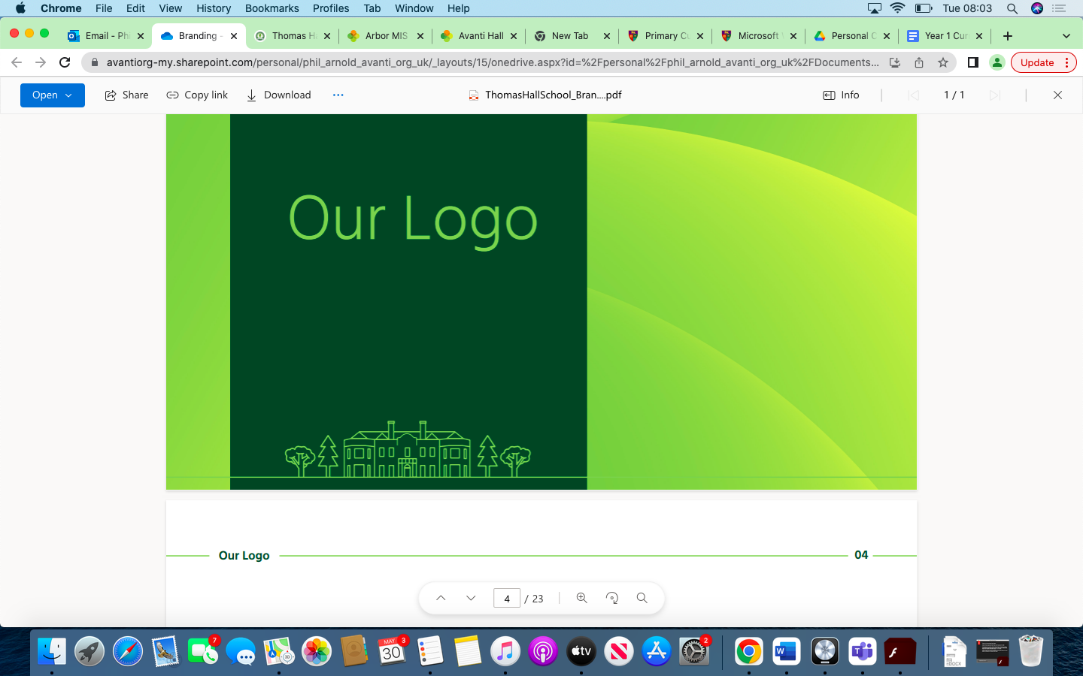

English Overview Thomas Hall School 2023-2024

|  |
| --- |
| Early Years and Key Stage 1 |
| Key Stage 2 |
| Key Stage 3 |
| Key Stage 4 |

|  |  |  |  |  |  |  |
| --- | --- | --- | --- | --- | --- | --- |
| **Year** | **Autumn 1** | **Autumn 2** | **Spring 1** | **Spring 2** | **Summer 1** | **Summer 2** |
| **Reception** | Read individual letters by saying the sounds for them.  Form lower-case and capital letters correctly.  Understand how to listen carefully and why listening is important.  Engage in story times.  Learn rhymes, poems and songs. | Read some letter groups that each represent one sound and say sounds for them.  Form lower-case and capital letters correctly.  Learn new vocabulary.  Use new vocabulary through the day.  Describe events in some detail.  Listen to and talk about stories to build familiarity and understanding.  Listen carefully to rhymes and songs, paying attention to how they sound.  Learn rhymes, poems and songs. | Blend sounds into words, so that they can read short words made up of known letter-sound correspondences.  Read a few common exception words matched to the school’s phonic programme.  Spell words by identifying the sounds and then writing the sound with letter/s.  **Anticipate (where appropriate) key events in stories.**  **Say a sound for each letter in the alphabet and at least 10 digraphs.**  **Read words consistent with their phonic knowledge by sound-blending.**  Ask questions to find out more and to check they understand  what has been said to them.  Use talk to help work out problems and organise thinking and activities, and to explain how things work and why they might happen.  Develop social phrases.  Retell the story, once they have developed a deep familiarity with the text, some as exact repetition and some in their own words.  Expressing their ideas whilst being aware of the listener. | Read simple phrases and sentences made up of words with known letter–sound correspondences and, where necessary, a few exception words.  Re-read these books to build up their confidence in word reading, their fluency and their understanding and enjoyment.  **Read aloud simple sentences and books that are consistent with their phonic knowledge, including some common exception words.**  **Read words consistent with their phonic knowledge by sound-blending.**  Articulate their ideas and thoughts in well-formed sentences.  Connect one idea or action to another using a range of connectives.  Use new vocabulary in different contexts.  Engage in non-fiction books.  Listening to others and responding appropriately.  **Make comments about what they have heard and ask questions to clarify their understanding.**  **Offer explanations for why things might happen, making use of recently introduced**  **vocabulary from stories, non-fiction, rhymes and poems when appropriate.** | Write short sentences with words with known letter-sound correspondences using a capital letter and full stop.  Re-read what they have written to check that it makes sense.  **Use and understand recently introduced vocabulary during discussions about stories, non- fiction, rhymes and poems and during role play.**  **Write recognisable letters, most of which are correctly formed.**  Listen to and talk about selected non-fiction to develop a deep  familiarity with new knowledge and vocabulary.  **Listen attentively and respond to what they hear with relevant questions, comments and actions when being read to and during whole class discussions and small group interactions.**  **Participate in small group, class and one-to-one discussions, offering their own ideas, using recently introduced vocabulary.** | **Write simple phrases and sentences that can be read by others. Spell words by identifying sounds in them and representing the sounds with a letter or letters. Demonstrate understanding of what has been read to them by retelling stories and narratives using their own words and recently introduced vocabulary.**  Listening to others and responding appropriately  **Hold conversation when engaged in back-and-forth exchanges with their teacher and peers.**  **Express their ideas and feelings about their experiences using full sentences, including use of past, present and future tenses and making use of conjunctions, with modelling and support from their teacher** |
| **Year 1** | Beegu  Where the Wild Things Are  The Storm Whale  The Owl & the Pussycat  Aesop’s Fables - The Boy Who Cried Wolf  Poetry – Pattern & Rhyme  Setting description 1  Instructional writing 1  Shape Poems & Calligrams 1  Stories with familiar settings 1 | | The Tale of Peter Rabbit  Look Up  Here We Are  Chocolate Cake  Shape Poems & Calligrams 2  Informal letters 1  Recount from personal experience 1  Poetry on a theme (nature) 1  Instructional writing 2  Stories with familiar settings 2 | | There’s a Rang Tan in my Bedroom  And Tango Makes Three  The Lion Inside  Aesop’s Fables - The Hare & The Tortoise  The Proudest Blue  Informal letters 2  Recount from personal experience 2  Poetry on a theme (nature) 2  Setting description 2  Poetry - Pattern & Rhyme | |
| **Year 2** | Grandad’s Island  Aesop’s Fables - The Goose that Laid the Golden Egg  Mrs Noah’s Pockets  Paddington  The Christmas Pine  Character Description 1  Simple Retelling of Narrative 1  Poetry - Developing Vocabulary 1  Formal Invitations 1  Stories from other cultures 1 | | The Quangle Wangle's Hat  Coming to England  The Street Beneath my Feet  Rhythm of the Rain  Little People: Big Dreams - David Attenborough  Poetry on a theme (humour) 1  Recount from personal experience 1  Formal Invitations 2  Stories from other cultures 2  Non chronological reports 1 | | Fantastically Great Women Who Changed the World  Aesop’s Fables - The Sun and the Wind  Fantastic Mr Fox  Character Description 2  Non chronological reports 2  Simple Retelling of Narrative 2  Poetry - Developing Vocabulary 2  Recount from personal experience 2  Poetry on a theme (humour) 2 | |
| **Year 3** | Greta & the Giants  The Pebble in My Pocket  Leon & the Place Between  The Night Before Christmas  Poetry on a theme (emotions) 1  Non-Chronological Reports 1  First person narrative 1  Dialogue through narrative (historical stories) 1  Formal complaint letter 1 | | Sam Wu is not Afraid of the Dark  Operation Gadgetman  Performance Poetry  Non-Chronological Reports 2  First person narrative 2  Advanced instructional writing 1  Third person narrative 1 | | The Dancing Bear  The Magician’s Nephew  Dialogue through narrative (historical stories) 2  Poetry on a theme (emotions) 2  Advanced instructional writing 2  Third person narrative 2  Formal complaint letter 2 | |
| **Year 4** | The Queen’s Nose  Young, Gifted & Black  The Raven  Poems which explore Form 1  Persuasive Writing 1 - Adverts  First Person Diary Entries 1  Analysis of Narrative Poetry 1  Third person Adventure stories 1  News Reports 1 | | The Girl who Stole an Elephant  The Boy at the Back of the Class  Stories from Other Cultures 1  Persuasive Writing 2  Explanatory texts 1  Stories from other cultures 1  Poems which explore form 2 | | Varjak Paw  The Wind in the Willows  Stories from Other Cultures 1  First person Diary entries 2  Analysis of Narrative Poetry 2  News Reports 2  Explanatory texts 2  Third Person Adventure Stories 2 | |
| **Year 5** | Shackleton’s Journey  Secrets of a Sun King  Third Person Stories set in Another Culture 1  Formal Letters of Application 1  Poems that use word Play 1  Dialogue in Narrative 1  Balanced Argument 1  Poems Which Explore Form 1 | | A Midsummer Night’s Dream  I am not a Label  Boy in the Tower  Daffodils  Third Person Stories set in another culture 1  Playscripts (retelling Shakespeare) 1  Formal Letters of Application 2  Biography 1  Poems that use Word Play 1 | | The Explorer  Five Children & It  Playscripts 2  Dialogue in Narrative  Balanced argument 2  Biography 2  Poems which explore form 2 | |
| **Year 6** | Rooftoppers  Pig Heart Boy  The Listeners  How to Live Forever  Autobiography 1  Discursive Texts  Poems that create images and explore vocabulary  First Person Stories with a moral 1  Shakespeare’s Sonnets 1  Explanatory Texts 1 | | All Aboard the Empire Windrush  The Island  Skellig  Extended Third Person Narrative 1  Explanatory Texts 2  News reports 1  Autobiography 2  First Person Stories with a moral 2 | | Dare to Be You  Oliver Twist  Extended Third Person Narrative 2  News reports 2  Discursive writing & speeches 2  Poems that create images 2  Shakespeare’s Sonnets 2 | |
| **Year 7** | ‘Fantastic Beasts’  *Students will improve their creative writing skills by looking at a range of texts from the fantasy genre.* | Outsiders  *Students will read a range of extracts from 19th Century texts. Introduction to PETER paragraphs and language analysis.* | ‘Shakespeare’s The Tempest  *Introduction to the analysis of Shakespeare used, prose and verse, iambic pentameter and learning about context and how language has developed, of plays and subplot as well as theatrical devices.* | Short Stories – Tales of the Unexpected  *Introduction to short story writing, as well as structure and literary techniques.* | Escape  *Exploration of the non-fiction genre, travel writing, essays, speeches and biographies.* | ‘FACE’  -Reading of a fiction text, what it is like to have a major injury, what life in like for some teens in the UK, and what it is like reading a text from someone from a different culture. |
| **Year 8** | Poetry  Love & Relationships    Understanding of the poetic form, key poets from the Literary Cannon and how to analyse and interpret a poem. PETER paragraphs and how to apply context to what they have read. | ‘Of Mice and Men’   Fiction Reading  Knowledge of the text, the Great Depression and life in America in 1930s as well as societal and cultural issues of the time. | “Body Image” Non-Fiction Writing  What features make non-fiction texts? How to adapt tone, persona and register and adaption of form to fit the different | "War Writing” Creative Writing    Understanding of the assessment criteria, development of sophisticated sentence structures and literary techniques. Exploration of existing war stories and building stamina for writing. | Goggle Eyes  Modern Drama  *Understanding how to write about and analyse language form and structure; as well as dramatization techniques such as stage directions and dramatic irony. To improve confidence reading aloud in front of others. To discuss and debate topical issues including different family units, relationships and how they change, extinction rebellion, animal rights, feminism, protesting, sexism, and racism.* | Introduction to Media Studies  *Students will be introduced to Media Studies and learn terminology useful for English such as bias, stereotype, genre conventions. We will explore the changing gender roles of men and women throughout medial and film* |
| **Year 9** | ‘Gothic Writing’    *Students will study and understand Gothic conventions in a text and improve creative writing skills. Exposure to texts from the literary cannon. Recapping of writing skills learnt in previous years with a focus on more ambitious with figurative language, sentence types and structures and awareness of the effects words can have on meaning.* | Poetry  - Anthology Poets and other works/ Unseen  *Students will study other works of the poets in the GCSE anthology in order to build knowledge of context as well as poetic forms and their confidence in spotting techniques. They will also hone their analytical skills in preparation for the Unseen element of Literature.* | Infamous Villains –  Non –Fiction Reading  S*tudents will deepen knowledge of how to answer the non fiction GCSE paper, using articles about famous villains to become familiar with the formula for each style of exam question, from summaries to comparison. They will improve skills in analysing language and effects.* | Shakespeare’s Macbeth    *Students will study a full Shakespeare text and revise Shakespearian conventions and become more familiar with the language and form.* | Creative Reading- Paper 1 intro  *Students will read a range of literature fiction texts in order to consider how established writers use narrative and descriptive techniques to capture the interest of readers.* | **Spoken word & writing speeches**  *Student will become familiar with a range of persuasive oral and written techniques and apply these to writing speeches.* |
| **Year 10** | ‘Power and Conflict poetry anthology’    **Knowledge:** *Students will learn the 15 poems for the examination, their contexts, messages and purposes as well as honing skills of how to analyse language, key words, identify poetic techniques and write a comparative essay.* | ‘A Christmas Carol’ by Charles Dickens  *Knowledge of the book, its context and Dicken’s attitude and methods for conveying this. Enhanced knowledge of cyclical structures and motifs and how they are used for effect. Language analysis and character development.* | ‘An Inspector Calls’  by JB Priestley  *Understanding of the plot, but building on from Dickens’ message from the Victorian era, Priestley’s socialist message, key themes of responsibility and integrity and his desire to drive social change as well as studying a play, the effect of stage directions, lighting and dramatic devices such as dramatic irony.* | ‘Macbeth’  by William Shakespeare  *Revision of the plot, chracters and events from the previous’ year. A more detailed look at Shakesperean language, prose, iambic pentamer and verse. Subversion of gender roles and audience reactions. Understanding of the context and the influence of pleasing the King on Shakespeare’s writing*. | Unseen Poetry  /  Revision  *Revision of all the texts, key ideas, characters, plots and contexts in preparation for the exam. Skills of analysis and AO2/writing about language.* | **Unit: Speaking and Listening / Non-Fiction writing.**    **Knowledge:**  *Knowledge of how to construct an effective speech, practise performing in front of an audience and to camera. Usage of persuasive techniques and how to structure spoken word for an impact on an audience. Ability to listen and respond to questions, developing ideas in more detail.* |
| **Year 11** | **Unit: Creative Writing – Language Paper 1 Section B**    Students will revise what makes a good story, practise using a range of structures and revise elements on grammar before  writing their own creative text to demonstrate their narrative and descriptive skills in response to a written prompt, scenario or visual image. | **Unit: Creative Reading – Language Paper 1 Section A**    Knowledge:  *reading a range of literature fiction texst in order to consider how established writers use narrative and descriptive techniques to capture the interest of readers* | **Unit: Non-Fiction Reading - Language Paper 2 Section A**    Knowledge:  *provide students with an opportunity to consider viewpoints and perspectives over time. Choice of genre will include high quality journalism, articles, reports, essays, travel writing, accounts, letters, autobiography and biographical passages or other appropriate non-fiction and literary non-fiction forms.* | **Unit: Non-Fiction Writing – Language Paper 2 Section B**      Knowledge:  *producing a written text to a specified audience, purpose and form in which they give their own perspective on the theme, students will need to demonstrate awareness of using a range of opinions, statements and writing scenarios to provoke a response.* | **Revision** |  |