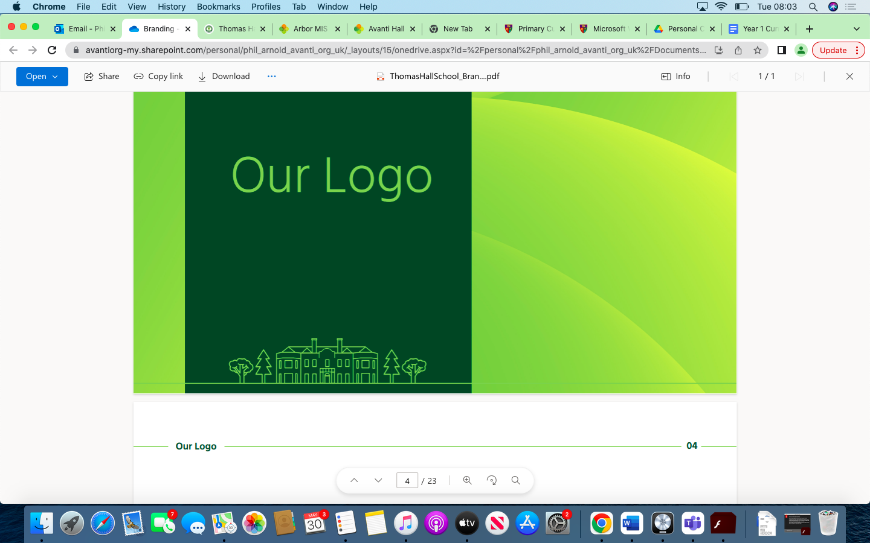

French Overview Thomas Hall School 2023-2024

|  |
| --- |
| Key Stage 2 |
| Key Stage 3 |
| Key Stage 4 |

|  |  |  |  |  |  |  |
| --- | --- | --- | --- | --- | --- | --- |
| **Year** | **Autumn 1** | **Autumn 2** | **Spring 1** | **Spring 2** | **Summer 1** | **Summer 2** |
| **Year 3** | Phonics  Greetings  Numbers 1-12  Classroom instructions | Phonics  Asking a question “As-tu…?”  Pencil case  French customs at Christmas | Classroom language  Animals  Colours  Singular / plural nouns and articles | Adjectives  Listening skills  Reading skills  Stories & songs | Fruit  Singular / plural nouns and articles  Days of the week  Food | To develop confidence and memory  Create a butterfly using knowledge of colours  Snack foods  Ordering food at a café |
| **Year 4** | Revision of greetings + classroom language  Numbers 1-31  Days + months  Dates  Seasons  Asking for and giving own birthday | Birthday celebration  Typical exclamations in French  Making a party invitation  Christmas vocabulary  Learning about la Fête des Rois | Shapes  Colours  Prepositions of place  Describing a photo  Describing Matisse pictures  Creating own picture + description | Parts of the face  Adjectives  Parts of the body  Designing + describing monster pictures | Family members  Learn the alphabet  Use the alphabet to spell names “Comment ça s’écrit?”  Asking and answering questions on siblings + pets  Describing hair + eyes | Describing hair + eyes  Describing paintings by Picasso + other artists  Describing a family |
| **Year 5** | Classroom language  Question words  Learning the 5 x table  Asking for and giving the time  Describing what you have for breakfast  Communicating likes + dislikes | Food + opinions  ER verb MANGER, to write short sentences about what different people eat for breakfast  To learn how to say you prefer  To practise saying what you eat + drink for lunch  Dictionary skills  Mealtimes and expressions of frequency  -ER regular verbs  Sentence building using verbs, time expressions and food | Sports + dictionary skills  Opinions on sport  Saying what sports you play  Jouer à + faire de with sports  Saying what sports you know how to play “je sais… “  Saying how often you do sports – expressions of frequency | Learn pronouns  Learn 6 verb endings + the layout of a verb table  Verb = Faire  Using verbs to give instructions  Create a simple exercise /dance routine | Revision of opinions  Opinions and different types of music  Dictionary skills  Identifying French words for instruments  Ask and answer which instrument you play  Verb = Jouer | Giving reasons with “parce que”, plus new adjectives  Using adjectives to give reasons for liking / disliking music or instrument  Interviews about music  Create own song / rap |
| **Year 6** | Classroom language  Questions  Phonics  Months  Describing the weather + seasons  Geography of France  Compass points | Countries, colours, flags  To say what several countries are famous for + opinions  To learn the name of the countries that border France  To describe what there is in France “il y a beaucoup de…”  To describe France and understand a longer text about France  To use the correct preposition for “in” when talking about countries and towns  To say where you live  Languages and nationalities in French. | To learn words for different areas/types of places to live  Talking about where you live in more detail  Dictionary skills  TO learn words to say what is in a town  To create sentences to say/write “il y a / il n’y a pas” and build a conversation  To explore a French poem  Memory and performance skills  To create their own version of a poem | French festivals using the present tense of “er” verbs.  Le Carnaval à Dunkerque  La fête des lumières à Lyon  Describing a festival in England  TO apply grammar (articles, adjectives, agreements and place)  Key verb forms, linking words. | Revision of essential personal identification vocabulary and structures, including questions  Prepare and perform conversation  Holidays vocabulary: Revision of where I live and weather  Holidays: Using the verb aller  Clothes introduction | Clothes recap and clothes poem  Fashion show introduction  Fashion show preparation and performance  At the café: Revision  Ice creams  Revision tasks: essential personal identification vocabulary and structures, including questions.  Revision tasks: Revision of places in the town, adjectives for describing places, high-frequency words, and core verbs |
| **Year 7** | Knowledge:  Introducing yourself.  Counting up to 31.  Talking about brother, sister and age.  Learning the French alphabet.  Talking about likes and dislikes.  Describing yourself and others.  Say what you are doing.  Skills:  To be able to greet people.  To be able to recognize sound patterns.  To be able to identify numbers.  To be able to use the verb “aimer” + the definite article.  Assessment:  Module 1 reading task. | Knowledge:  Saying what subjects, you study.  Consolidating the present tense.  Talking about colours.  Telling the time.  Talking about what your wear.  Talking about your school day.  Skills:  To talk about likes and dislikes using er verbs.  Using adjectives after nouns.  Using “er” verbs.  Assessment:  Module 2 listening task and dictation task.  Vocabulary tests. | Knowledge :  Saying what you do in your free time.  Talking about weather and seasons.  Talking about sports in the present tense.  Saying what you like to do.  Skills:  To use jouer à.  To use the verb faire.  To be able to use aimer + the infinitive.  Assessment:  Module 3 writing task.  Vocabulary tests. | Knowledge :  Talking about your family.  Talking about your pets.  Saying where you live.  Talking about breakfast. Skills:  To use possessive adjectives  To form the present tense  To use partitive articles  Assessment:  Translation task  Vocabulary tests.. | Knowledge:  Naming places in your town.  Ordering in a café.  Understanding prices in French.  Saying what you are going to do.  Skills:  To use aller and vouloir  To be able to use 2 tenses together.  To use the near future tense  Assessment:  Module 5 speaking task.  Vocabulary tests. | Unit:  Project Task -  Tout sur moi booklet.  Create a booklet all about themselves in French.  Knowledge :  Revision and consolidation of work covered in Yr. 7.  Skills :  Revision of skills from across the year.  Tour sur moi booklet  Revision project  Create a booklet all about themselves in French.   Assessment:  Photo description task + 40 word writing task. |
| **Year 8** | Knowledge:  Talking about school holidays.  Saying what you did during the holiday.  Describing a visit to a theme park.  Saying where you went and how.  Skills:  To be able to use the past tense of regular “er” verbs.  To be able to use the perfect tense of irregular verbs.  Using the perfect tense of verbs that take “être”.  Assessment:  Vocabulary tests. | Knowledge :  Describing festivals and special days.  Shopping for food.  Talking about a future trip.  Skills:  Using present tense -ir and -re verbs.  Using transactional language.  Using the near future.  Assessment:  Reading and listening tasks.  Vocabulary Tests. | Knowledge:  Talking about digital technology.  Talking about leisure activities.  Saying what you bought.  Skills:  To be able to agree nouns with adjectives.  Using the perfect tense.  Using the negative.  Using 3 tenses in a piece of writing  Assessment:  Module 3 writing task - photo description and 40 words writing task. | Knowledge: Talking about where you live.  Saying what you do to help at home.  Talking about your daily routine  Skills:  Using pouvoir + inf.  Looking for different persons of the verb.  Using reflexive verbs.  Assessment:  Module 4 speaking task.  Vocabulary tests. | Knowledge :  Talking about sports and giving opinions  Asking and giving directions  Skills:  Using jouer à + jouer de.  Using the comparative.  Using the imperative.  Using il faut.  Assessment:  Module 5 listening task + Dictation.  Vocabulary tests. | Knowledge :  Talking about injuries and illnesses.  Skills:  Role play conversations.   Assessment:  Speaking task.  90 word writing task.  Cultural project  Impressionism  Students learn about the different artists and their work.  Students describe paintings |
| **Year 9** | Knowledge :  Talking about digital technology.  Talking about leisure activities.  Saying what you bought.  Skills:  To be able to agree nouns with adjectives.  Using the perfect tense.  Using the negative.  Assessment:  Vocabulary tests. | Knowledge:  Talking about where you live.  Saying what you do to help at home.  Talking about your daily routine  Skills:  Using pouvoir + inf.  Looking for different persons of the verb.  Using reflexive verbs.  Assessment:  Photo description and 40 word writing task.  Vocabulary tests. | Knowledge :  Talking about sports and giving opinions.  Asking and giving directions.  Talking about injuries and illnesses.  Skills:  Using jouer à + jouer de.  Using the comparative.  Using the imperative.  Using il faut.  Role play conversations.  Assessment:  Module 5 speaking task.  Vocabulary tests. | Knowledge :  Describing your friends.  Describing birthday celebrations.  Talking about what you want to do when you are older.  Talking about what you will do in the future.  Skills:  Using reflexive verbs.  Using the perfect tense.  Using “vouloir”.  Using the simple future tense.  Assessment:  90 word writing task  Vocabulary tests. | Knowledge:  Describing what you used to be like.  Comparing your primary and secondary schools.  Talking about food.  Discussing eating habits.  Skills:  Using the imperfect tense.  Using the comparative.  Describing a photo.  Using a range of negatives.  Assessment:  Listening and reading tasks.  Vocabulary tests. | Knowledge:  Talking about animals and the natural world.  Talking about what you would like to do. Skills:  Using the superlative.  Using the conditional tense. Assessment:  150 word writing task.  Vocabulary tests. |
| **Year 10** | Unit :  Studio AQA-Module 1  Knowledge:  Revising family and describing people  Revising places in town and activities  Talking about relationships  Making arrangements to go out  Describing a night out  Talking about life when you were younger  Discussing role models Skills: Using irregular verbs in the present tense  Using reflexive verbs in the present tense  Using the near future tense  Using the perfect tense  Using the imperfect tense  Assessment:  40 word writing task. | Unit:  Studio AQA-Module 2  Knowledge :  Revising sport and music  Revising technology, films and TV  Talking about sport  Talking about life online  Talking about books and reading  Talking about television programmes  Talking about actors and films  Skills :  Using depuis + the present tense  Using the comparative  Practice the imperfect tense  Using direct object pronouns (le, la, les)  Using superlative adjectives  Assessment:  90 word writing task and translation task. | Unit:  Studio AQA-Module 3  Knowledge :  Talking about food and meals  Discussing and shopping for clothes  Describing your daily life  Talking about food for special occasions  Using polite language  Describing family celebrations  Describing festivals and traditions  Skills :  Using pouvoir and devoir  Using the pronoun en  Asking questions in the tu and vous form  Using venir de + infinitive  Using a combination of tenses  Assessment:  Listening and writing tasks | Unit:  Studio AQA-Module 4 Knowledge :  Talking about where you live, weather + transport  Describing a town and asking the way  Describing a region  Talking about your town, village or district  Discussing what t9o see and do  Discussing plans and the weather  Describing community projects  Skills :  Using the pronoun y  Using negatives  Asking questions using quel/quelle/quels/quelles  Using the future tense  Using the present, perfect and future tenses  Assessment:  Photo description and 90 word writing task. | Unit:  Studio AQA-Module 5 Knowledge :  Talking about what you normally do on holiday  Talking about holidays (past, present, future)  Talking about an ideal holiday  Booking and reviewing hotels  Ordering in a restaurant  Talking about travelling  Buying souvenirs  Talking about holiday disasters  Skills :  Using the conditional  Using reflexive verbs in the perfect tense  Using en + the present participle  Using avant de + the infinitive  Using demonstrative adjectives and pronouns  Using the pluperfect tense  Assessment:  150 word writing task. | Unit:  GCSE revision and speaking practice.  Past paper practice.  Assessment:  Speaking task – speaking exam. |
| **Year 11** | Unit:  Studio AQA-Module 5 Knowledge :  Talking about what you normally do on holiday  Talking about holidays (past, present, future)  Talking about an ideal holiday  Booking and reviewing hotels  Ordering in a restaurant  Talking about travelling  Buying souvenirs  Talking about holiday disasters | Unit:  Studio AQA-Module 6  Knowledge:  Revising school subjects and talking about timetable  Talking about your school  Comparing school in the UK and French-speaking countries  Discussing school rules  Discussing healthy living  Discussing vices  Talking about a school exchange  Skills:  Using the pronouns il and elle  Using the pronouns ils and elles  Using il faut and il est interdit de  Using the imperative  Using the present and future tenses  Using past, present and future timeframes  Assessment: | Unit:  Studio AQA-Module 7  Knowledge:  Discussing jobs and work preferences  Discussing career choices  Talking about plans, hopes and wishes  Applying for jobs  Understanding case studies  Skills:  Saying better/worse” and the best/worst thing”  Understanding the subjunctive  Using direct object pronouns in the perfect tense  Using verbs followed by à or de  Assessment:  Writing past paper | Unit:  Studio AQA-Module 8  Knowledge:  Talking about what makes you tick  Discussing problems facing the world  Talking about protecting the environment  Discussing ethical shopping  Talking about volunteering  Discussing big events  Skills:  Making connections between word types  Using the modal verbs pouvoir and devoir in the conditional  Using the passive  Using indirect object pronouns  Giving arguments for and against  Assessment:  Mock Exams. | Unit:  GCSE revision and exam practice.  Assessment:  Reading and Listening past papers | Unit:  GCSE revision and exam practice.  Assessment:  Writing past paper. |