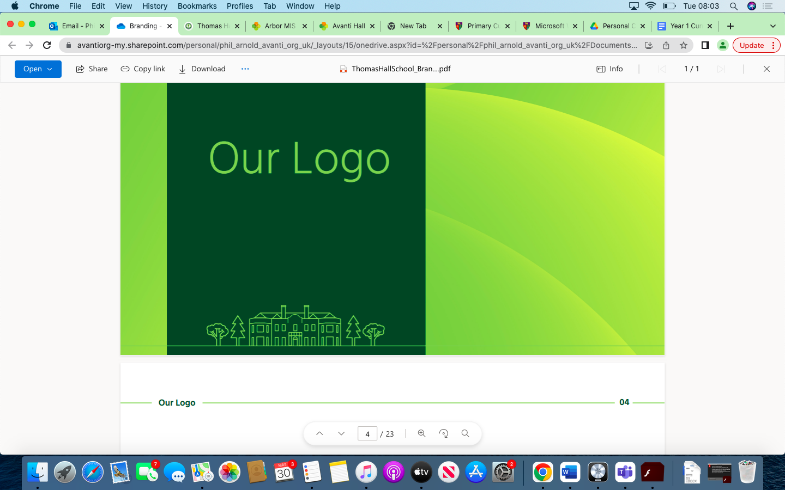

Computing Overview Thomas Hall School 2023-2024

|  |
| --- |
| Early Years and Key Stage 1 |
| Key Stage 2 |
| Key Stage 3 |
| Key Stage 4 |

|  |  |  |  |  |  |  |
| --- | --- | --- | --- | --- | --- | --- |
| **Year** | **Autumn 1** | **Autumn 2** | **Spring 1** | **Spring 2** | **Summer 1** | **Summer 2** |
| **Reception** | To be able to recognise objects that are electrical – plugs/batteries etc. | To be able to use/access/complete a program | To understand that computers can be a source of information.  To be able to use/access/complete a program | To understand that computers can be a source of information.  To be able to use/access/complete a program | Describe their immediate environment using knowledge from observation,  discussion, stories, non-fiction texts and maps.  To be able to use/access/complete a program | Describe their immediate environment using knowledge from observation,  discussion, stories, non-fiction texts and maps.  To be able to use/access/complete a program |
| **Year 1** | Using a Computer | Programming | Skills Showcase - Rocket to the Moon | Programming 2 - Beebot | Creative Media - Digital Imagery | Data Handling – Introduction to data  Online Safety |
| **Year 2** | Using a Computer | Programming | Computer Systems - Word Processing | Programming - Scratch Jnr | Creative Media - Stop Motion Animation | Data Handling  Online Safety |
| **Year 3** | Online safety  Networks & the internet | Programming 1 – Scratch | Computer Systems - email | Inside a Computer | Creative Media - Video Trailers | Data Handling – Comparison Cards / Databases |
| **Year 4** | Online safety  Computer systems & Networks | Programming 1 – Further Coding with Scratch | Creating Media – Website Design | Skills showcase – HTML | Programming 2 - Computational Thinking | Data Handling – Investigating Weather |
| **Year 5** | Online safety  Computer systems – Search Engines | Programming 1 – Music | Programming 2 - Micro:Bit | Data Handling – Mars Rover | Skills showcase – Inventing a Product | Creating Media – Stop Motion animation |
| **Year 6** | Singing | Music Technology | Introducing Structure 2 | Musical Notation 4 | Composition 4 | Improvisation 2 |
| **Year 7** |  |  |  |  |  |  |
| **Year 8** |  |  |  |  |  |  |
| **Year 9** |  |  |  |  |  |  |
| **Year 10** |  |  |  |  |  |  |
| **Year 11** |  |  |  |  |  |  |