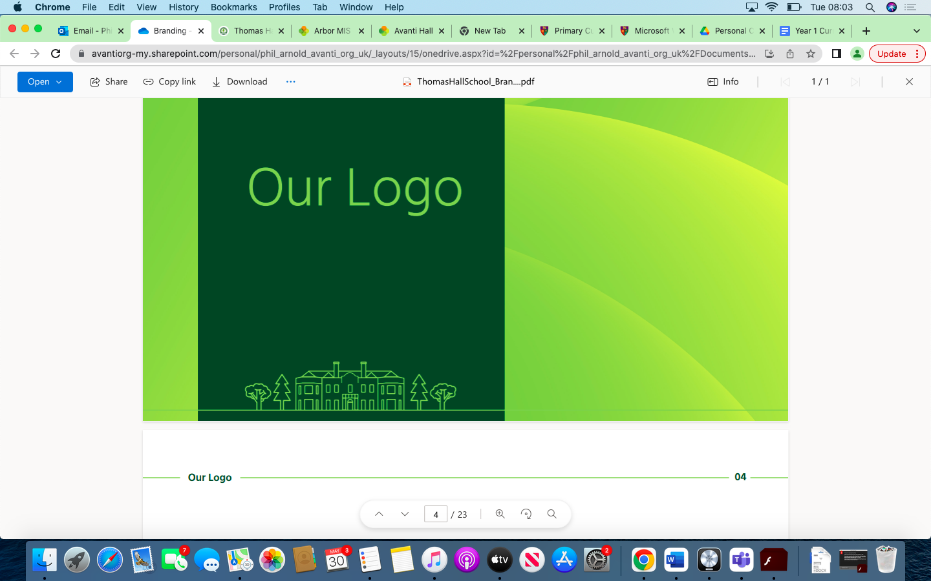

Overview Thomas Hall School 2023-2024

|  |
| --- |
| Key Stage 3 |
| Key Stage 4 |

|  |  |  |  |  |  |  |
| --- | --- | --- | --- | --- | --- | --- |
| **Year** | **Autumn 1** | **Autumn 2** | **Spring 1** | **Spring 2** | **Summer 1** | **Summer 2** |
| **Year 7** |  |  |  |  |  |  |
| **Year 8** |  |  |  |  |  |  |
| **Year 9** |  |  |  |  |  |  |
| **Year 10** |  |  |  |  |  |  |
| **Year 11** |  |  |  |  |  |  |