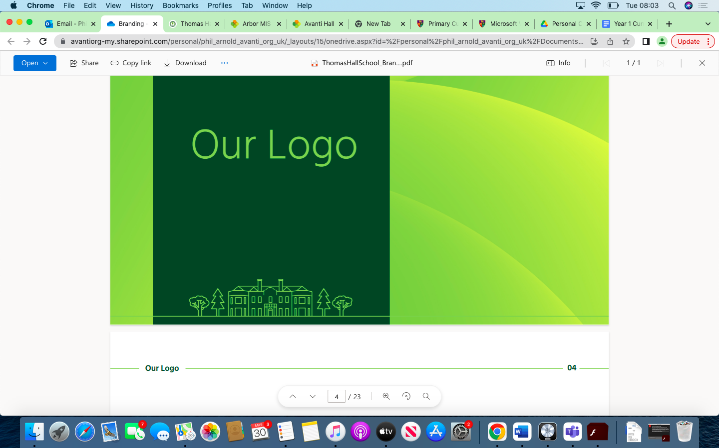

RE Overview Thomas Hall School 2023-2024

|  |
| --- |
| Early Years and Key Stage 1 |
| Key Stage 2 |
| Key Stage 3 |
| Key Stage 4 |

|  |  |  |  |  |  |  |
| --- | --- | --- | --- | --- | --- | --- |
| **Year** | **Autumn 1** | **Autumn 2** | **Spring 1** | **Spring 2** | **Summer 1** | **Summer 2** |
| **Reception** | Explore similarities among families, communities and traditions. | Explore similarities among families, communities and traditions. | Recognise that people have different beliefs and celebrate special times in different ways. | Recognise that people have different beliefs and celebrate special times in different ways. | Know some similarities and differences between different religious and cultural communities in this country, drawing on their experiences and what has been read in class | Know some similarities and differences between different religious and cultural communities in this country, drawing on their experiences and what has been read in class |
| **Year 1** | What do Christians believe God is like? | Why does Christmas matter to Christians? | Who do Christians say made the world? | Who is Jewish and how do they live? | | What makes some places sacred to believers? |
| **Year 2** | What is the good news Christians believe that Jesus brings? |  | What does is mean to belong to a faith community | Why does Easter Matter to Christians | Who is a Muslim and how do they live? | How should we care for others and the world, and why does it matter? |
| **Year 3** | Worship, Pilgrimage and Sacred Places | Nativity | Symbols and Religious expression (Christianity & Hinduism) | | Teaching & Authority (Christianity & Hinduism) | |
| **Year 4** | What kind of world did Jesus want? | What do Hindus believe god is like? | Why do Christians call the day Jesus died ‘Good Friday’? | What does it mean to be a Hindu in Britain today? | For Christians, what was the impact of Pentecost? | How and why do people mark the significant events of life? |
| **Year 5** | What does it mean if Christians Believe God is Holy & Loving? | For Christians, what kind of king is God? | Why do Hindus try to be good? | Why do some people believe in God, and some not? | What matters most to Humanists & Christians? | How do Christians decide how to live? What would Jesus do? |
| **Year 6** | What does it mean to be Muslim in Britain today? | How does faith help when life gets hard? | Why is the Torah so important to Jewish people? | Why do Christians believe Jesus was the Messiah? | What do Christians believe that Jesus did to save people? | Creation and science: conflicting or complementary? |
| **Year 7** | The Island: Building a society  Then  Who am I?  Who am I as an individual and a human? | What is Freedom ?  Jewish history and the commandments. | Did Jesus exist?  Who do Christians believe Jesus is? | Christianity in Exeter  A study of two churches | What is Sanatana Dharma?  Hindu beliefs about God | What is Sanatana Dharma?  Hindu beliefs about reincarnation (samsara) |
| **Year 8** | What kind of world do I live in?      Signs and Symbols, Myths, environmental issues | What is morality?  An introduction to ethical decision making. | IS religion good for society?  A study of SIkhism with a focus on sewa. | Who owns Jerusalem?      History and conflict in the Holy Lands | What does it mean to be a Muslim?    Key beliefs, 5 pillars. | What does it mean to be a Muslim?    Key beliefs, 5 pillars. |
| **Year 9** | Does God exist?  Classical arguments for the existence of God | Does God exist?  Classical arguments for the existence of God | Christianity Beliefs and teachings  AQA RS GCSE A | Christianity Beliefs and teachings  AQA RS GCSE A | Christianity Practices  AQA RS GCSE A | Christianity Practices  AQA RS GCSE A |
| **Year 10** | Religion and Life  AQA RS GCSE A | Religion and Life  AQA RS GCSE A | Component 1: Second religion The study of religions: beliefs, teachings and practices  AQA RS GCSE A | Component 1: Second religion The study of religions: beliefs, teachings and practices    AQA RS GCSE A | Component 1: Second religion The study of religions: practices  AQA RS GCSE A | Component 1: Second religion The study of religions: practices    AQA RS GCSE A |
| **Year 11** | Religion and family | Religion, Crime and Punishment. |  |  |  |  |