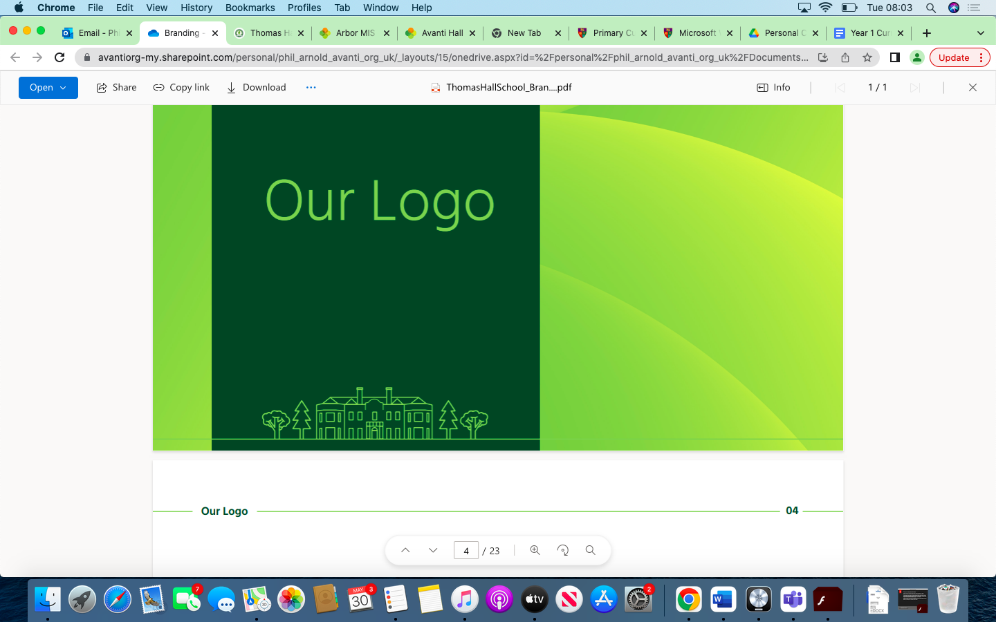

Science Overview Thomas Hall School 2023-2024

|  |
| --- |
| Early Years and Key Stage 1 |
| Key Stage 2 |
| Key Stage 3 |
| Key Stage 4 |

|  |  |  |  |  |  |  |
| --- | --- | --- | --- | --- | --- | --- |
| **Year** | **Autumn 1** | **Autumn 2** | **Spring 1** | **Spring 2** | **Summer 1** | **Summer 2** |
| **Reception** | Explore the natural world around them.  Describe what they see, hear and feel whilst outside.  Understand the effect of changing seasons on the natural world around them. | Explore the natural world around them.  Describe what they see, hear and feel whilst outside.  Understand the effect of changing seasons on the natural world around them. | Describe their immediate environment using knowledge from observation,  discussion, stories, non-fiction texts and maps.  Explore the natural world around them, making observations and drawing pictures of animals and plants. | Describe their immediate environment using knowledge from observation,  discussion, stories, non-fiction texts and maps.  Explore the natural world around them, making observations and drawing pictures of animals and plants. | Recognise some environments that are different to the one in which they live. | Know some similarities and differences between the natural world around them and contrasting environments, drawing on their experiences and what has been read in class.  Understand some important processes and changes in the natural world around them, including the seasons and changing states of matter. |
| **Year 1** | Seasonal Changes  Plants | Animals Including Humans | Animals Including Humans  Everyday Materials | Everyday Materials | Revisit Plants | Revisit Animals Including Humans |
| **Year 2** | Living things & their Habitats | Animals Including Humans | Everyday Materials | Revisit Animals Including Humans & Everyday Materials | Plants | Revisit Animals including Humans & Plants |
| **Year 3** | Rocks and Soils | Revisit Rocks & Soils | Animals Including Humans | Forces & Magnets | Plants | Light |
| **Year 4** | Living Things & Their Habitats | States of Matter | Animals Including Humans, Teeth & Digestion | Animals Including Humans – Food Chains | Electricity | Sound |
| **Year 5** | Properties & Changes in Materials | Animals Including Humans - Changes | Introduce Forces | Earth & Space | Living Things and Their Habitats | Revisit: Living Things and Their Habitats |
| **Year 6** | Electricity | Animals Including Humans – Circulatory System | Light | Living Things & Their Habitats - Classification |  | Evolution & Inheritance |
| **Year 7** | Starting Science  Organisms – movements and cells  nature and universe | Forces- speed and gravity  Earth- structure and universe | Energy costs and energy transfer  Genes – human variation and reproduction | Matter – particle model and separating mixtures  Waves – sound and light | Ecosystems – interdependence and plant reproduction  Reactions – metal, Earth | Electromagnetics – voltage resistance and current  Science Project for Expo |
| **Year 8** | Forces – *Contact forces and Pressure*    Spring Extension  Footprint pressure  Organisms  Measuring Breathing  Food tests | Earth – *Climate and Earth Resources*  Energy – *Work and Heating and cooling* | Genes – *Evolution and Inheritance*  Matter – *Periodic table and Elements* | Waves – *Wave effects and Wave properties*  Ecosystem – *Respiration and Photosynthesis* | Reactions – *Chemical energy and Types of reaction*  Electromagnets – *Magnetism and Electromagnetism* | Science Project for Expo |
| **Year 9** | Skills Development/GCSE Prep (4 weeks)  Cell Biology | Atoms & Periodic Table  Energy | Organisation  Structure & Bonding | Particle Model  Infection & response | Chemical changes  Energy Changes | RP Temperature change |
| **Year 10** | Electricity  Bioenergetics | Organic Chemistry  Atomic Structure | Homeostasis and Response  Rates of Reaction | Waves  Ecology | Using Resources  Forces | Chemistry of the Atmosphere |
| **Year 11** | Genetics  Chemical Changes | Wave types and properties  Electromagnetic Spectrum | Evolution and Classification  Forces in Equilibrium | Humans and biodiversity  Forces in motion | Revision | Exams |